AI Assistant Coding
ASSIGNMENT – 6.1
P.Harshit
2303A51159
TASK-1 :
Use an AI code completion tool to generate a loop-based
program.
Prompt:
“Generate Python code to print all even numbers between 1 and N
using a loop.”
CODE :
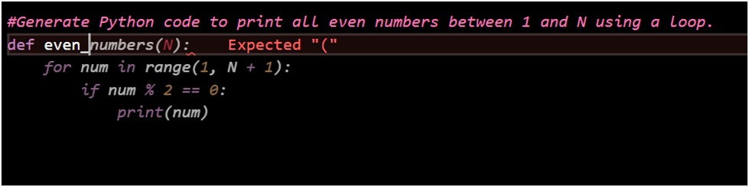

OUTPUT :
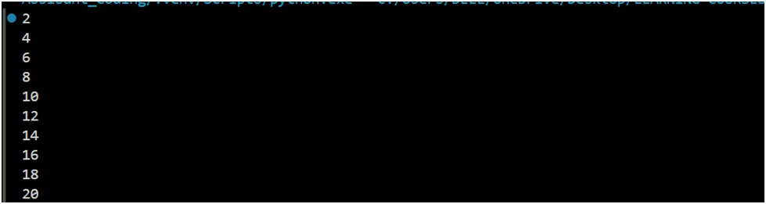
EXPLAINATION :
AI generated a Python program using a for loop.
Loop iterates from 1 to N.
Condition checks for even numbers.
Prints all even numbers in the given range.

TASK 2 :
Use an AI code completion tool to combine loops and
conditionals.
Prompt:
“Generate Python code to count how many numbers in a list are even
and odd.”
CODE :
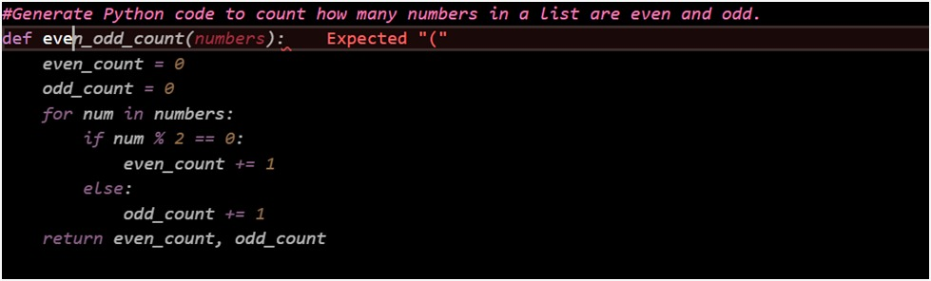
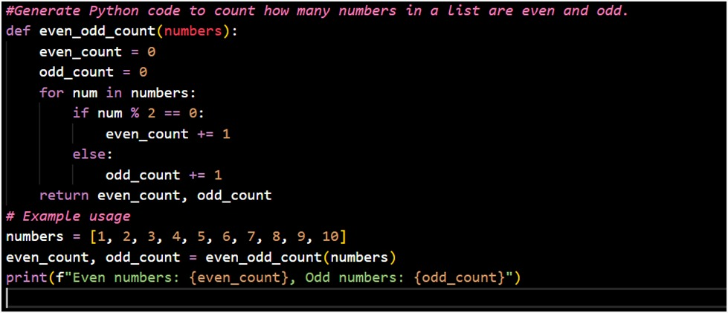
OUTPUT :
EXPLAINATION :
AI used a loop to traverse a list.
If–else condition checks even or odd.
Separate counters maintain even and odd count.
Final counts are displayed.

TASK 3 :
Use an AI tool to complete a Python class that validates user
input.
Prompt:
“Generate a Python class User that validates age and email using
conditional statements.”
CODE :
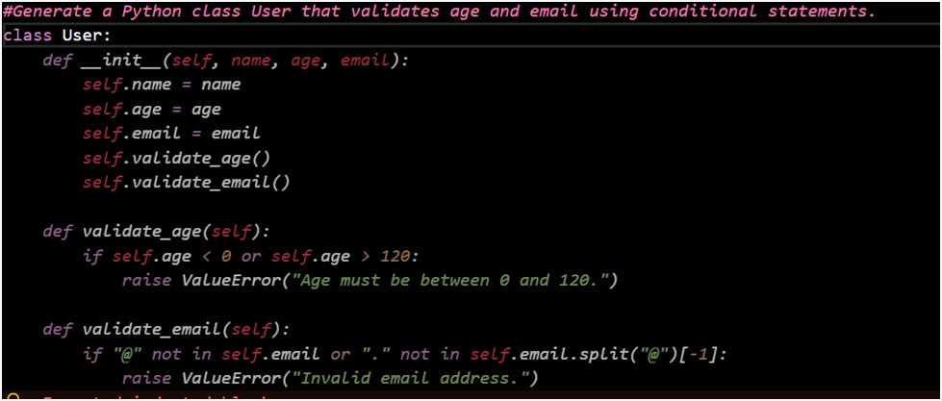
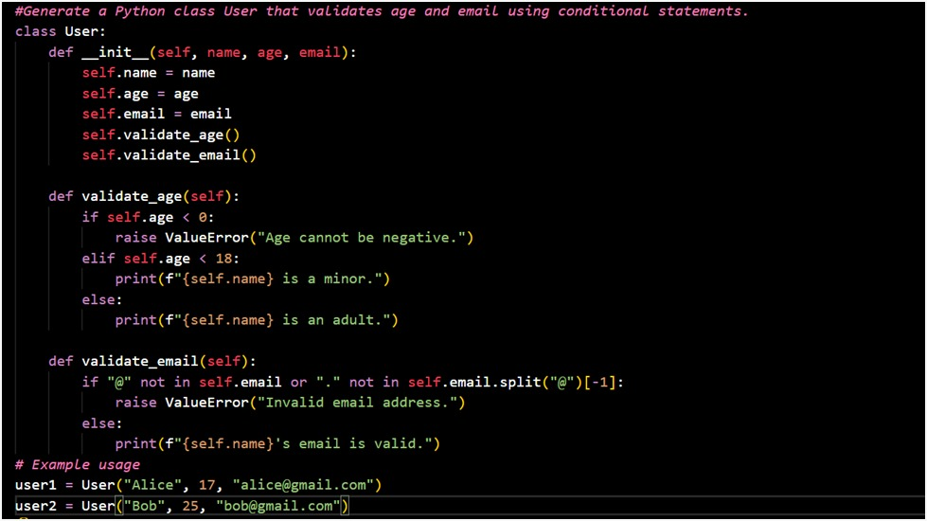
OUTPUT :
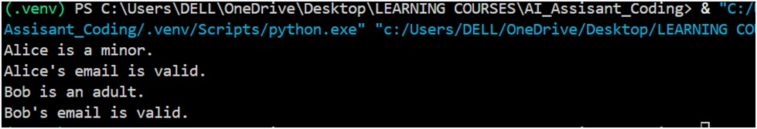
EXPLAINATION :
AI generated a User class.
Uses conditional statements for validation.
Validates age and email input.
Handles valid and invalid cases correctly.

TASK 4 :
Use an AI code completion tool to generate a Python class for
managing student details.
Prompt:
“Generate a Python class Student with attributes (name, roll number,
marks) and methods to calculate total and average marks.”
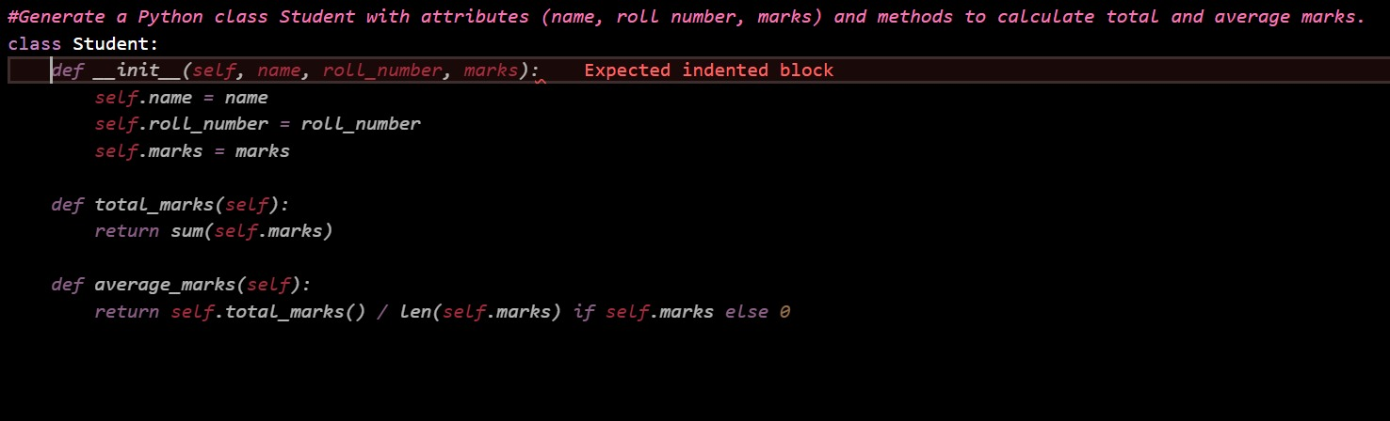
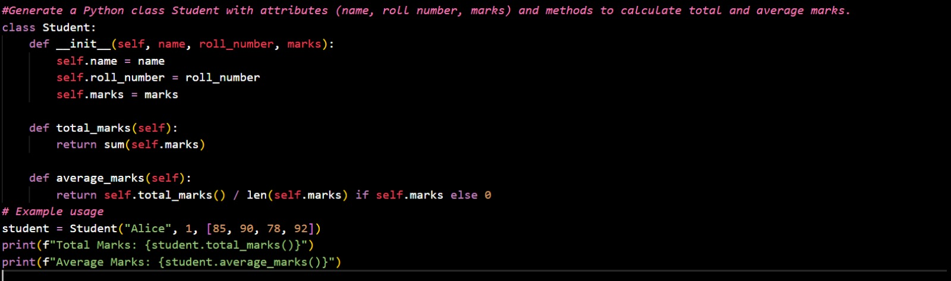
OUTPUT :
EXPLAINATION :
AI created a Student class.
Stores name, roll number, and marks.
Methods calculate total and average marks.
Demonstrates proper class structure.

TASK 5 :
Use an AI tool to generate a complete Python program using
classes, loops, and conditionals together.
Prompt:
“Generate a Python program for a simple bank account system using
class, loops, and conditional statements.”
CODE :
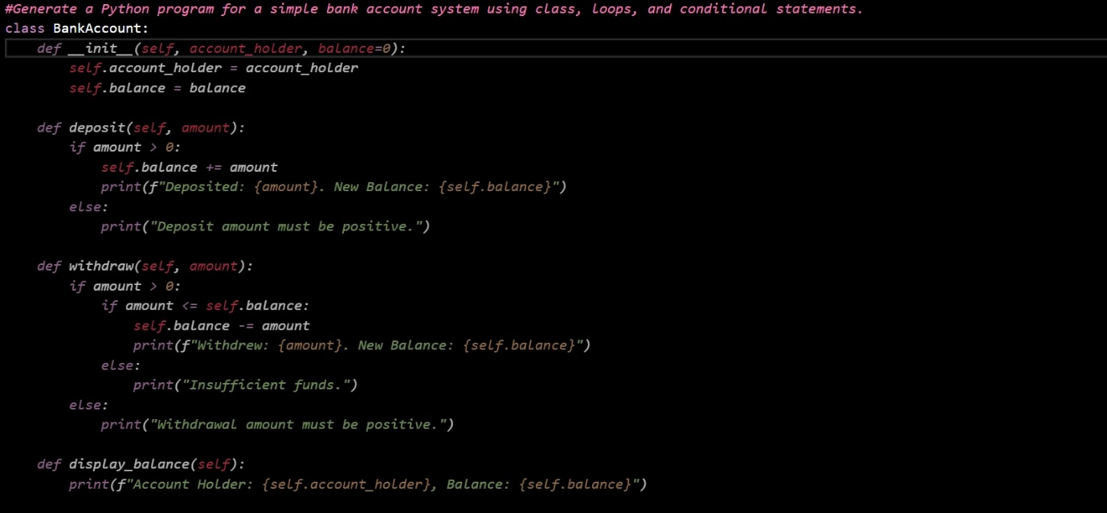
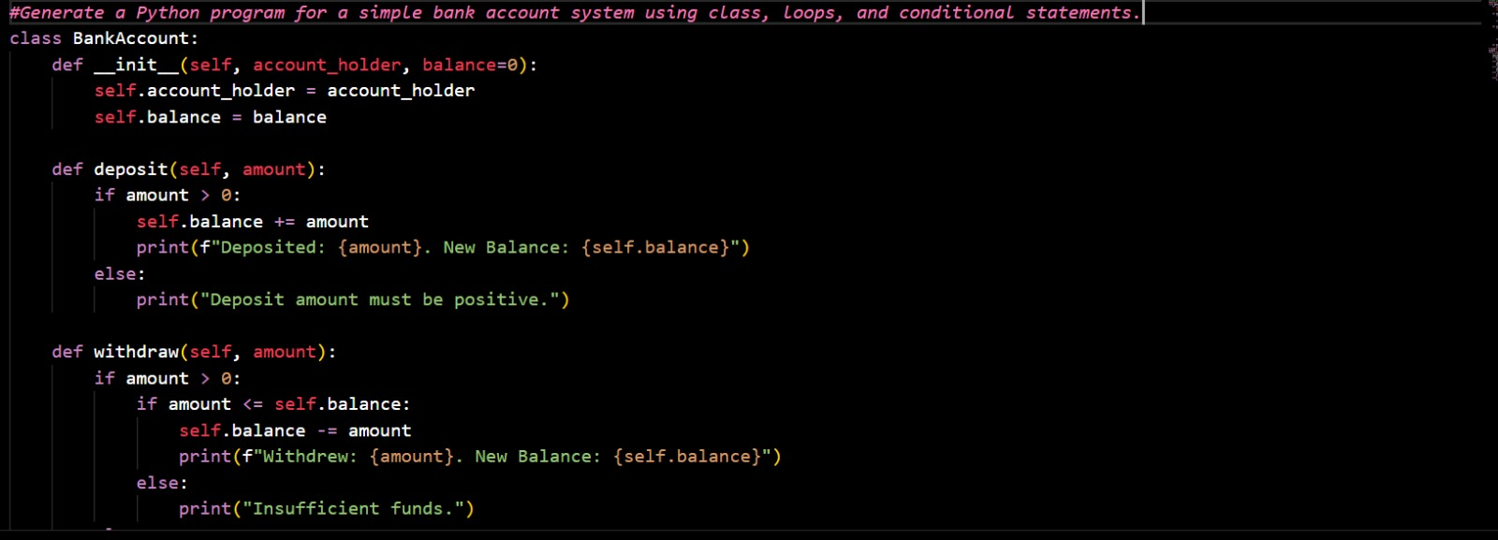
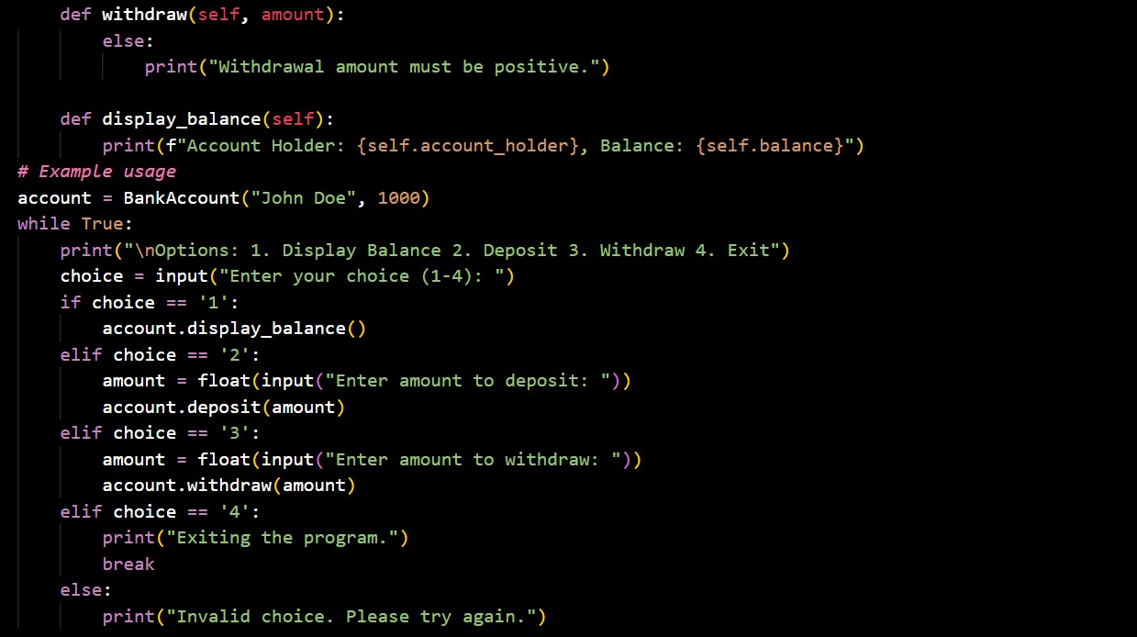
OUTPUT :
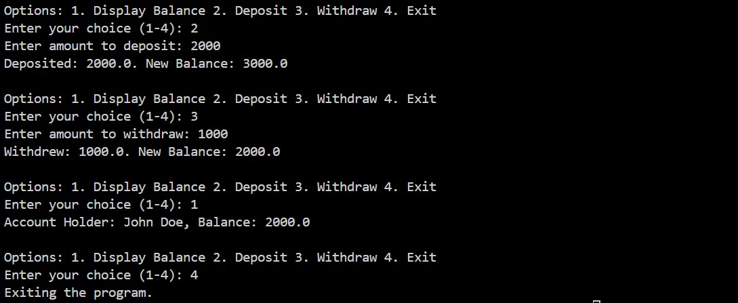
EXPLAINATION :
AI generated a bank account system program.
Uses class, loop, and conditionals together.
Menu-driven operations (deposit, withdraw, display).
Improves coding speed and productivity.

